

A Course End Project Report on

Complaint Registration and Tracking System using Java

A9602 - Object Oriented Programming through Java

Submitted by

Thakur Kanishka – 25881A05CW

Course Facilitator
Mr. Ganesh Deshmukh
Assistant Professor

Department of Computer Science And Engineering
Vardhaman College of Engineering, Hyderabad

October 2026

Contents
- Introduction 3
- Literature Review 3
- Objectives 3
- Methodology 3
  - Block Diagram 3
  - Circuit Diagram and Components 3
  - Working Principle 4
  - Software Implementation 4
- Results and Discussion 4
- Mapping POs and SDGs 5
  - Program Outcomes (POs) Mapping 5
  - Sustainable Development Goals (SDGs) Mapping 5
- Conclusion 5
Bibliography 6

Abstarct
The manual process of registering and managing complaints can be time-consuming, inefficient, and difficult to track. Traditional complaint management systems often involve paperwork and manual communication, which may lead to delays in resolving complaints and difficulties in maintaining records. To overcome these challenges, this project presents a Complaint Registration and Tracking System using Java, designed to simplify and organize the complaint management process through a computerized application.
The proposed system allows users to register complaints by providing the necessary details, such as complaint description, category, and other relevant information. Each complaint can be assigned a unique identification number, enabling users to track its status and monitor the progress of its resolution. The system also supports administrators in viewing registered complaints, managing complaint records, updating complaint statuses, and maintaining organized information. Java is used to develop the application, while Java Swing provides a graphical user interface for user interaction. MySQL is used to store and manage complaint details, allowing data to be retrieved and updated efficiently.
The main objective of this project is to provide a simple, user-friendly, and efficient platform for complaint registration and tracking. By reducing paperwork and improving record management, the system aims to enhance transparency, accessibility, and efficiency in the complaint-handling process. This project can be adapted for use in educational institutions, offices, hostels, and other organizations. Future enhancements may include email notifications, role-based authentication, and online complaint submission to improve accessibility and functionality.
Keywords: Complaint Registration, Complaint Tracking, Java, Java Swing, MySQL, Database Management, Complaint Management System.

Introduction
Complaint management is an important process in educational institutions, offices, and other organizations. Traditional complaint registration methods involve paperwork and manual communication, making it difficult to maintain records and track complaint status efficiently.
The Complaint Registration and Tracking System using Java is developed to simplify the complaint management process. It allows users to register complaints and enables administrators to view complaints, manage records, and update their status. Each complaint can be assigned a unique identification number for easy tracking and identification.
The system uses Java for application development, Java Swing for the graphical user interface, and MySQL for storing complaint details. JDBC is used to connect the Java application with the database, enabling efficient storage and retrieval of information.
The main aim of this project is to reduce paperwork, improve record management, and provide a simple and organized approach to complaint handling. The system can be used in colleges, hostels, offices, and other organizations to improve the efficiency and transparency of the complaint resolution process.

Literature Review
Existing complaint management systems use manual records or computerized applications to register and manage complaints. Traditional methods often involve paperwork, which can make complaint tracking and record maintenance difficult. Computerized systems help overcome these limitations by organizing complaint details and simplifying the process of monitoring complaint status.
Java-based applications provide a suitable approach for developing complaint management systems. Java Swing can be used to create a user-friendly graphical interface, while MySQL provides a structured way to store and manage complaint records. JDBC enables communication between the application and the database.
The proposed Complaint Registration and Tracking System integrates these technologies to provide an organized, efficient, and user-friendly solution for registering complaints, maintaining records, and tracking their resolution status.

Objectives
The main objectives of the Complaint Registration and Tracking System using Java are:
- To develop a computerized system for registering and managing complaints.
- To enable users to submit complaints with relevant details.
- To provide a unique complaint ID for easy identification and tracking.
- To allow administrators to view complaints and update their status.
- To store and retrieve complaint records efficiently using a MySQL database.
- To reduce paperwork and improve the efficiency of complaint management.
- To provide a simple and user-friendly graphical interface using Java Swing.

Methodology

Block Diagram
The Complaint Registration and Tracking System consists of the following components:
- User Interface: Allows users to register and track complaints.
- Java Application: Processes complaint details and manages system operations.
- MySQL Database: Stores and retrieves complaint records.
- Administrator: Views complaints and updates their status.
- JDBC: Connects the Java application with the database.
The system enables efficient complaint registration, record management, and status tracking through Java and MySQL.

Circuit Diagram and Components

Components Used
Components Used:
- Java – Application development
- Java Swing – Graphical user interface
- MySQL – Database management
- JDBC – Database connectivity
- XAMPP – MySQL database server management
These components work together to provide an efficient system for registering complaints, storing records, and tracking complaint status.

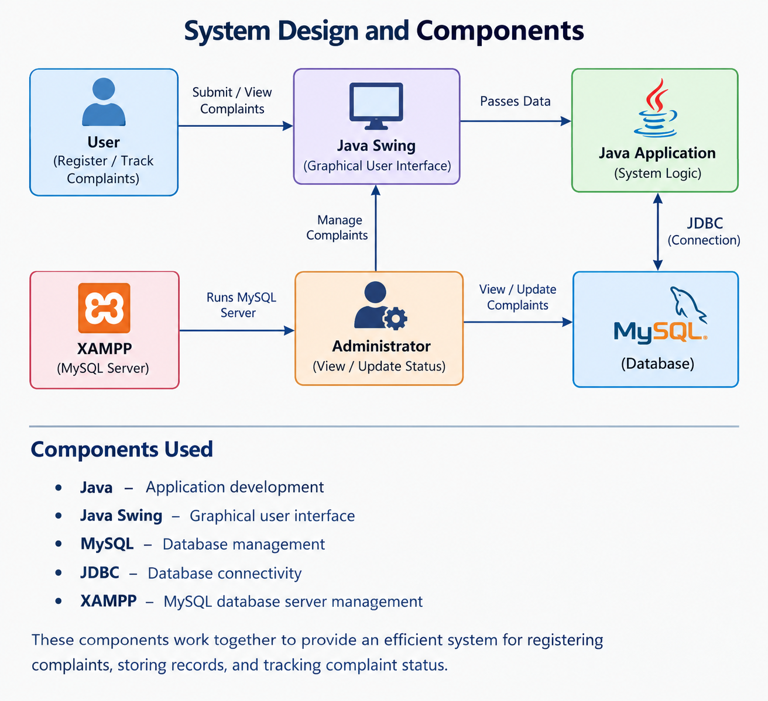

Figure 1: System Design and Components of Complaint Registration and Tracking System Using Java

Working Principle
- The Complaint Registration and Tracking System works by integrating a Java application with a MySQL database to manage complaints efficiently.
- Complaint Registration: The user opens the application and enters the required details, such as name, complaint category, and description of the problem.
- Data Validation: The system checks the entered information to ensure that the required fields are filled correctly before registering the complaint.
- Database Storage: The complaint details are stored in the MySQL database using JDBC, allowing the information to be maintained and retrieved whenever required.
- Complaint Management: The administrator views the registered complaints, examines the reported issues, and updates their status based on the progress of resolution.
- Complaint Tracking: Each complaint is identified using a unique complaint ID, which helps users check the status of their registered complaints.
- Status Updates: The complaint status can be updated to Pending, In Progress, or Resolved, helping users and administrators monitor the progress of complaint resolution.
- This process provides an organized approach to complaint registration, record maintenance, and status tracking while reducing manual work and improving the efficiency of complaint management.

Software Implementation
The Complaint Registration and Tracking System is implemented using Java and MySQL. The following software technologies are used in the development of the application:
- Java: Used to develop the application and implement complaint registration and management operations.
- Java Swing: Used to create a graphical user interface with forms, buttons, and tables for user interaction.
- MySQL: Used to store and manage complaint details, including complaint descriptions and status.
- JDBC: Used to establish a connection between the Java application and the MySQL database.
- XAMPP: Used to start and manage the MySQL database server.
These technologies work together to provide an organized platform for registering complaints, storing records, and tracking complaint status efficiently.

Results and Discussion

The Complaint Registration and Tracking System is implemented using Java and MySQL. The following software technologies are used in the development of the application:
- Java: Used to develop the application and implement complaint registration and management operations.
- Java Swing: Used to create a graphical user interface with forms, buttons, and tables for user interaction.
- MySQL: Used to store and manage complaint details, including complaint descriptions and status.
- JDBC: Used to establish a connection between the Java application and the MySQL database.
- XAMPP: Used to start and manage the MySQL database server.
These technologies work together to provide an organized platform for registering complaints, storing records, and tracking complaint status efficiently.

Mapping POs and SDGs

Program Outcomes (POs) Mapping

Table 1: Mapping of Program Outcomes (POs) to Project Relevance
PO.NO | Program Outcomes | Relevance
PO1
  Engineering Knowledge
  Applies Java programming
  and database management
  concepts.
PO2 |  | Identifies the difficulties of manual complaint registration and tracking.
  Problem Analysis
PO3
  Design/Development of Solutions
  Develops a computerized complaint registration and tracking system. | elops a computerized complaint registration and tracking system.
PO4 |  | Utilizes Java Swing, MySQL, JDBC, and XAMPP.
  Modern Tool Usage
PO5 |  | Provides a practical solution for efficient complaint management in organizations.
   | Engineer and Society
    Engineer and Society
    Engineer and Society

Sustainable Development Goals (SDGs) Mapping

Table 2: Mapping of Sustainable Development Goals (SDGs) to Project Relevance
SDG No. | Goal | Relevance
SDG 9 | Industry, Innovation, and Infras-tructure | Promotes the use of digital technology for efficient complaint management.
SDG 11 | Sustainable Cities and Communities | Reduces paper usage through digital complaint registration and record maintenance.
SDG 12 | Responsible Consumption and Pro-duction | Supports transparency and accountability through organized complaint tracking.

Conclusion
The Complaint Registration and Tracking System using Java provides an efficient and user-friendly solution for managing complaints. The system simplifies complaint registration, maintains records using a MySQL database, and enables administrators to update complaint statuses. By integrating Java Swing, JDBC, and MySQL, the application reduces paperwork and improves the organization and tracking of complaints. It can be used in colleges, hostels, offices, and other organizations. Future enhancements may include email notifications, improved security, and online complaint tracking to make the system more accessible and efficient.

Bibliography
[1] Oracle, “Java Documentation,” Oracle. Available: https://docs.oracle.com/en/java/
[2] Oracle, “Java Swing Tutorial,” Oracle. Available: https://docs.oracle.com/javase/tutorial/uiswing/
[3] Oracle, “JDBC Basics,” Oracle. Available: https://docs.oracle.com/javase/tutorial/jdbc/
[4] MySQL, “MySQL Reference Manual,” Oracle. Available: https://dev.mysql.com/doc/
[5] Apache Friends, “XAMPP Documentation.” Available: https://www.apachefriends.org/
[6] Herbert Schildt, Java: The Complete Reference, McGraw-Hill Education.

